MANAV RACHNA UNIVERSITY
Department of CST
(Artificial Intelligence – CSH205B-T & P)
Tutorial 3

Learning Outcomes: Search Algorithms

Course Outcome | Bloom’s Taxonomy | Program Outcome
CO2 | BT3, BT4 | PO1, PO2, PO3, PO4, PO5, PO12

1. Suppose you are searching for a girl’s name written using only the letters D, N and A. You have the letters ordered alphabetically (A, D, N) and you start writing down possibilities:
A, D, N, AA, AD, AN, DA, DD, DN, NA, ND, NN, ...
- How many strings of four or fewer letters are there where the letters are D, N or A?
- In the above possibilities, are you searching in a depth first or breadth first way? Justify your answer.
- What are the next three possible names you would write down?
- How many possibilities will you write down before getting to the name ANNA? [difficult]
- Are you guaranteed to find all girls names with letters D, N and A in this manner?

2. Suppose you are using a gradient descent search with the evaluation function “number of queens which are threatened by another queen” in the 8-queens problem. Suppose that you’re at the following board state:

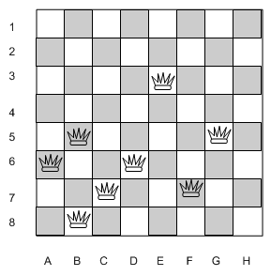

a) What is the current score for the evaluation function?

b) Write down some of the best moves from this position (queens can be moved anywhere).

c) Give an example of an illegal move (in a gradient descent search).

d) What do you do if there are no legal moves?

